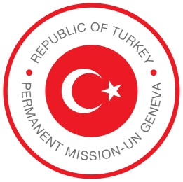

STATEMENT BY THE PERMANENT MISSION OF
THE REPUBLIC OF TURKIYE
CONFERENCE ON DISARMAMENT

22 February 2022

CHECK AGAINST DELIVERY

Thank you, Madam President.

Since this is the first time we take the floor during your Presidency of the Conference on Disarmament, we would like to begin by congratulating you and extending our full support.

We also would like to express our appreciation of the efforts of your Presidency, the Presidency of Ambassador Li Song of China and other members of the P6 for the adoption of the decision establishing the Subsidiary Bodies on the agenda items of the Conference after a 3-year break.

We believe that the decision provides the best available alternative under the current circumstances.

This is an important moment in our collective endeavours to bring back the Conference to substantive work on our agenda items.

It is now again up to us to build on this achievement and continue with substantive discussions in the Subsidiary Bodies.

Our delegation will actively and constructively participate in the discussions that will be held under the Subsidiary Bodies, and we expect the same spirit from all members of the Conference.

Last but not least, we also express our support in advance to the Coordinators of the Subsidiary Bodies for the efficient functioning of the groups.

Thank you, Madam President.

